Digital card automatization:

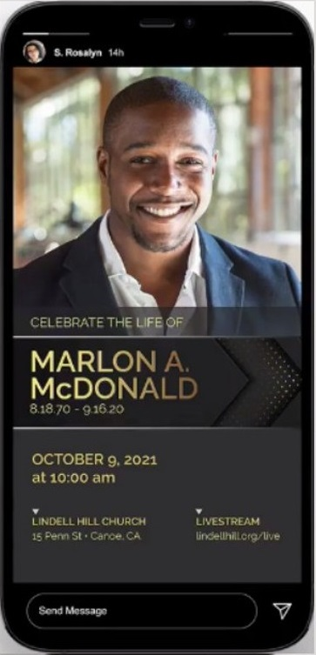 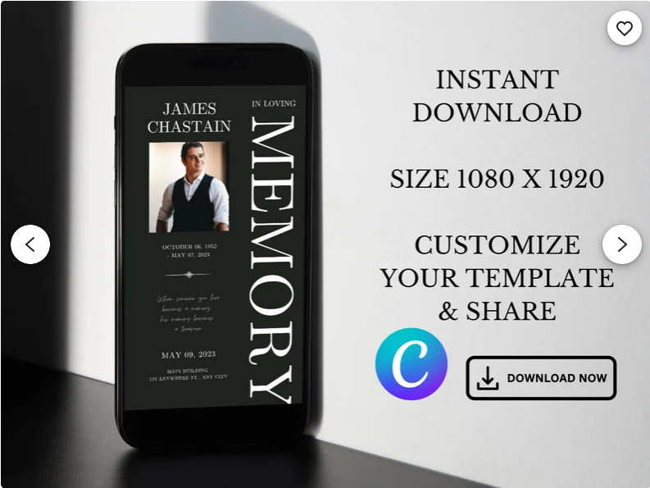

The idea is to offer them cards like these, so they can download them and send them to their relatives and friends.

By doing that they will be doing us a huge (unforced) promotion, because all cards (will later) have a second page where there is a link to our website and QR code (and maybe a sponsor = florist who would give these cards away and thus make us promotion.

These above are some premium cards that will be payable later, so i didn't want to include them right now; atm we would offer just some basic designs: invitation to funeral (so the closest relative to passed away sends these further to others), Our condolences (where others send them to closest ones; i want to attract them all ofc, so florists will be advertising these to just everybody, not just to closest to passed away) and 1x Thank you card (again for the closest ones to send it to others).

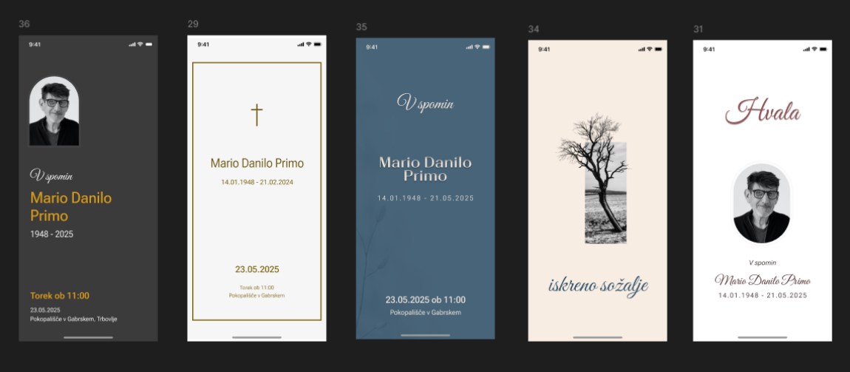

So these cards are done already (you will just make a change in the last line – to show Cemetery instead of what it is now).

So users will find these digital cards in memory page here, but they will not be available to download.

Instead they will have to visit our florists, who would send them their selected pic for free (takes 1 minute only, but florist will be glad to do this because they will get a griefing customer in their shop who is apparently going to funeral, so it is likely that they will buy something while there). We are bringing them customers that are ready to buy – buy right now at this moment.

So how will florists actually gave them our cards... They have the gift form in their user account and when user comes around, then they would just enter users username (email in this case since we don't have usernames for login) and find the passed away in the database and select a digital card they want. 3 fields only, done in 1 minute.

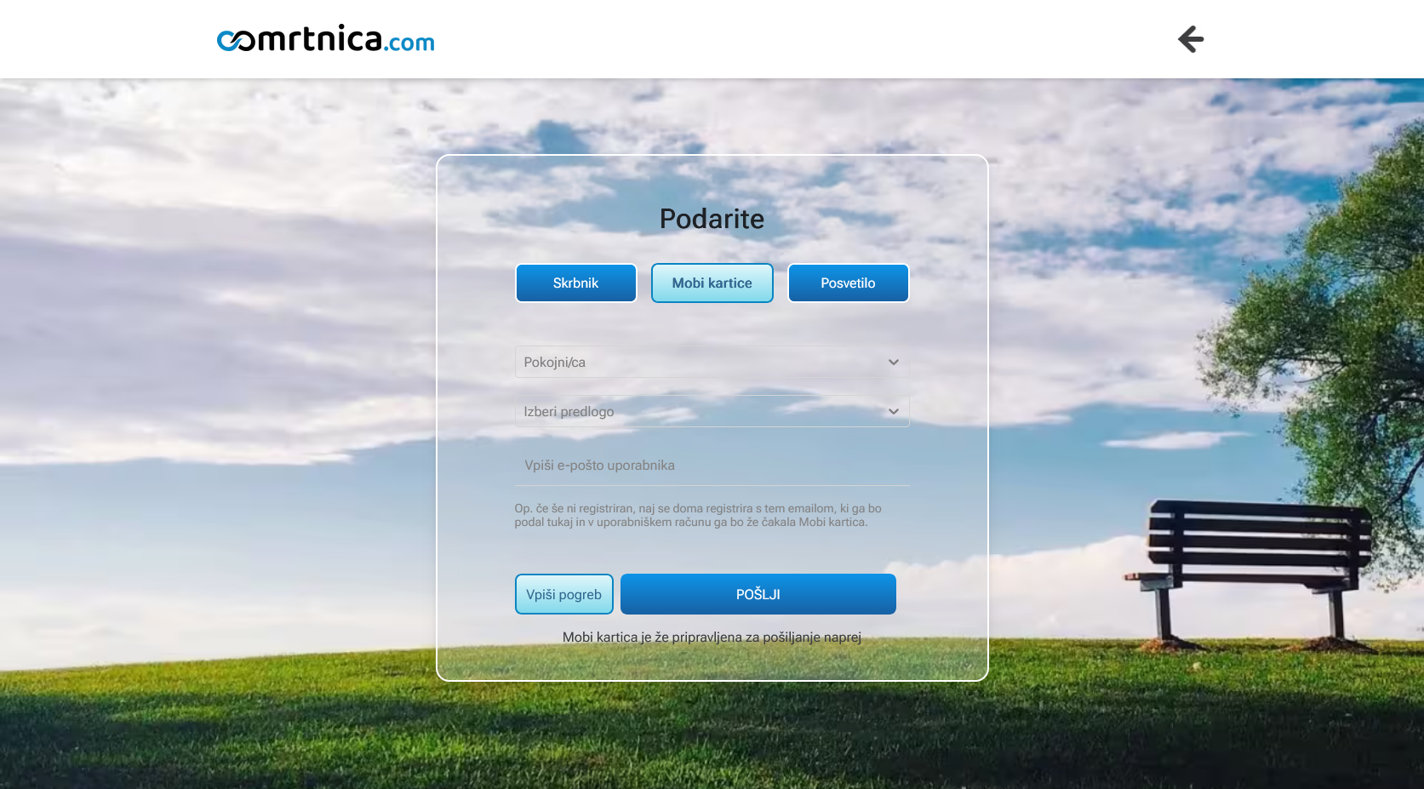

<https://dev111.osmrtnica.com/darila> (you have to be logged as a company to access this);

try as a florist [c15@ya.com](mailto:c15@ya.com) Banana1! (or c25, c30, c33, c35) or p15 and same.

When they send it, then that digital card is 'sent' directly to user's account (and not their email), so users can get it right away – while still in the shop and they can start sending these cards to others right away over their mobile (and if seniors, then florists can help them in this case). So everyone gets something great. Customers what they wanted and all the help from florists, florists get best possible customers who are looking things to buy right now and we too.

Same concept (and thus more gifts for customers and florist) IS ALREADY used for Monthly Keeper (a privilege to be an administrator of that particular memory page). This is already working perfectly – that particular user becomes a Keeper with all the privileges; the only thing needed will be some sort of notification in users account, so they would know they are keepers now. Note: we will not even offer Monthly keeper on our website, but only florists will (we will only sell yearly or 6 years keeper, but not give away monthly for free).

I will not be explaining how exactly works all there, because that's not needed right now and because ALL is working perfectly there – PLEASE do NOT change anything there. There is properly set which obits exactly are shown in dropdown, how it works if there is no funeral added, how can send these cards further, all is working perfectly.

What is NOT done, but it needs to be:

– to make digital cards be properly shown on memory pages

(right now default cards are shown instead of personalized – this changed few days ago; it's a minor bug)

(one single thing needs a change in digital cards ->> and that is the last line –>> where funeral? We will add to be shown just cemetery there, nothing else – while right now there is ' v City ' shown there).

– to actually transfer these gifts to user accounts (and NOT their emails) via gift form

So the idea is users will get a notification in their accounts where they can download their digital card (for cards) OR they will get a notification that they just became Keepers (this is set already and working properly – they become keepers for 2 months for free; so here only notification popup / message is needed + on /darila page it should be connected in a way that user gets that precise selected card).

– to make auto-conversion into a pdf file

(needs to be pdf like all digicards are + we will need pdf anyway) <https://www.etsy.com/market/digital_funeral_invitations>

Please make sure to not change any other thing there than these here.